

# CARE POINT

Laser Welder Settings – Gas Bottle

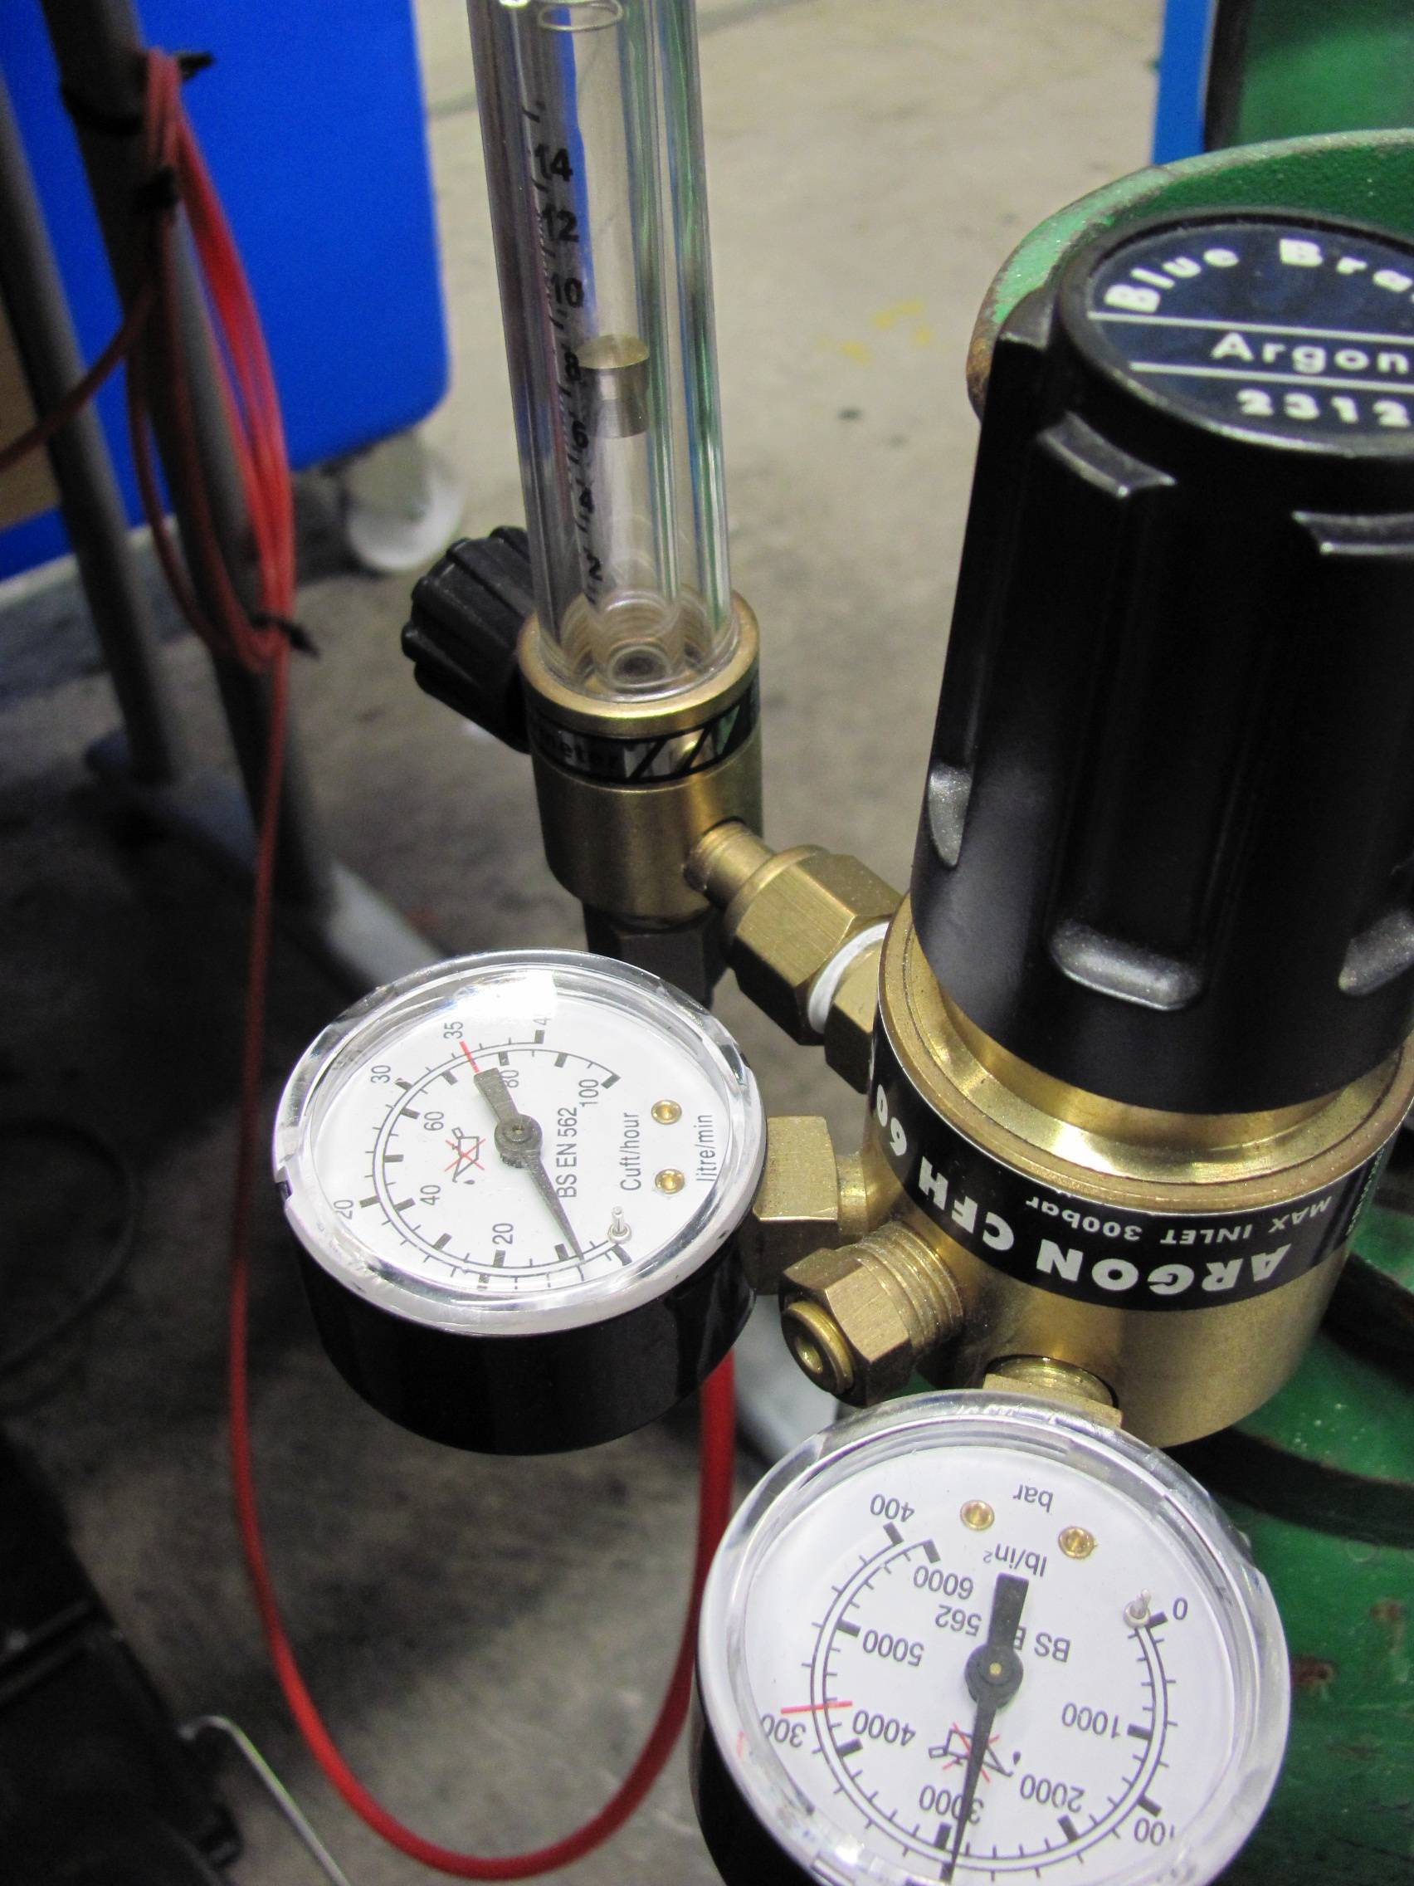

Fine Adjust – bubble should rise half way up tube when foot-pedal depressed.

This gauge shows how much gas is being delivered to the weld. It need only be set to 10 on the inner scale!

This gauge shows how much gas is in the bottle

Check settings whilst foot pedal is being depressed